**✅ 1. Core Java for Standalone Applications**

(Backend basic language + basic libraries)

**⭐ What is Core Java in Standalone Apps?**

Core Java is the **basic Java language** used to write the **logic of a desktop application**.

**✔ Core Java acts as the “backend” for standalone apps.**

Meaning:

* It handles calculations
* It stores/retrieves data
* It performs actions when a user clicks buttons
* It performs file operations (save/open)
* It controls the application flow

**⭐ Example “Concepts” of Core Java used in desktop apps:**

Below are simple examples of what parts of Core Java we use in standalone apps:

**⭐ Core Java Concepts — Short Notes (Simple & Clean)**

**✅ Classes & Objects**

Classes are blueprints that group related data and actions into one unit to keep the program organized.  
Objects are real examples created from these classes, and they perform the actual work inside the application.

**✅ Collections**

Collections help store many items like notes, songs, tasks, etc.  
List/Set/Map make it easy to manage and access this data inside the app.

**✅ File Handling**

File handling is used to save and load data like text files, settings, or documents.  
It lets the app read/write files so users can store their work permanently.

**✅ Exception Handling**

Exception handling prevents the app from crashing when errors occur (like divide by zero or missing files).  
Using try–catch keeps the application safe and provides proper messages.

**✅ Multithreading**

Multithreading allows the app to do multiple tasks at the same time, like playing music while updating the UI.  
It keeps the application smooth, fast, and responsive.

**⭐ Common Notes (Applies to all concepts above)**

**✔ 1. Feature / Concept**

All the above topics are **features/concepts** of Core Java that help build strong desktop applications.

**✔ 2. Library / Package**

Java provides different **packages/libraries** to support these features, such as:

* java.lang → OOP, exceptions, threads
* java.util → collections
* java.io → file handling
* java.util.concurrent → advanced threading

These libraries contain ready-made classes that help implement the concepts easily.

**⭐ UI Technologies for Standalone Apps — Very Simple Notes**

UI technologies help us create the **screens** of a desktop app.  
They give ready-made items like **windows, buttons, text boxes, menus, tables**, etc.  
They are called **UI libraries**, but sometimes people also call them **UI technologies**.

**⭐ Java UI Libraries**

**✔ AWT**

* Very old
* Very basic
* Not used today

**✔ Swing**

* Common Java UI library
* Good for making full desktop apps
* Used mostly in older projects

**✔ JavaFX**

* Modern Java UI
* Looks better and supports animations, charts, CSS
* Used in new desktop apps

**⭐ Industry Usage**

* AWT → Not used
* Swing → Used in legacy (old) apps
* JavaFX → Used in modern desktop apps

**⭐ Alternatives Used More Today**

* **C# (.NET)**
* **Python (Tkinter/PyQT)**
* **Electron (JavaScript)**
* **C++/Qt**

Companies prefer these more than Java UI for new desktop apps.

# ⭐ ****Advanced Java Technologies (Foundation Technologies)****

These are the **oldest and original technologies** used to build Java web applications.

## ✔ **1. JDBC** (Database Technology)

**Full form:** Java Database Connectivity

* JDBC is a **technology + API** to connect Java programs with databases.
* You can run SQL queries from Java using JDBC.
* It is the **lowest-level** database communication method.

👉 JDBC does things like:

* connect to MySQL/Oracle/PostgreSQL
* insert/update/delete/select records
* read values from database

But JDBC requires **too much code** → boilerplate.

## ✔ **2. Servlets** (Backend Technology)

* Servlet is a **technology** used to build the backend of web applications.
* It handles **HTTP requests and responses**.
* When you type a URL, the request is handled by a Servlet at the backend.

**Example:**  
You click “Login” → the form request goes to a Servlet → Servlet checks credentials → sends response.

Servlet = basic backend controller.

## ✔ **3. JSP (Java Server Pages)** (Frontend + Server-side)

* JSP helps you create **dynamic web pages**.
* It mixes HTML + Java to build UI.
* It is used along with Servlet.

### Servlets → Backend logic

### JSP → Frontend UI

So in old applications:

Browser → Servlet → JSP → Response to browser

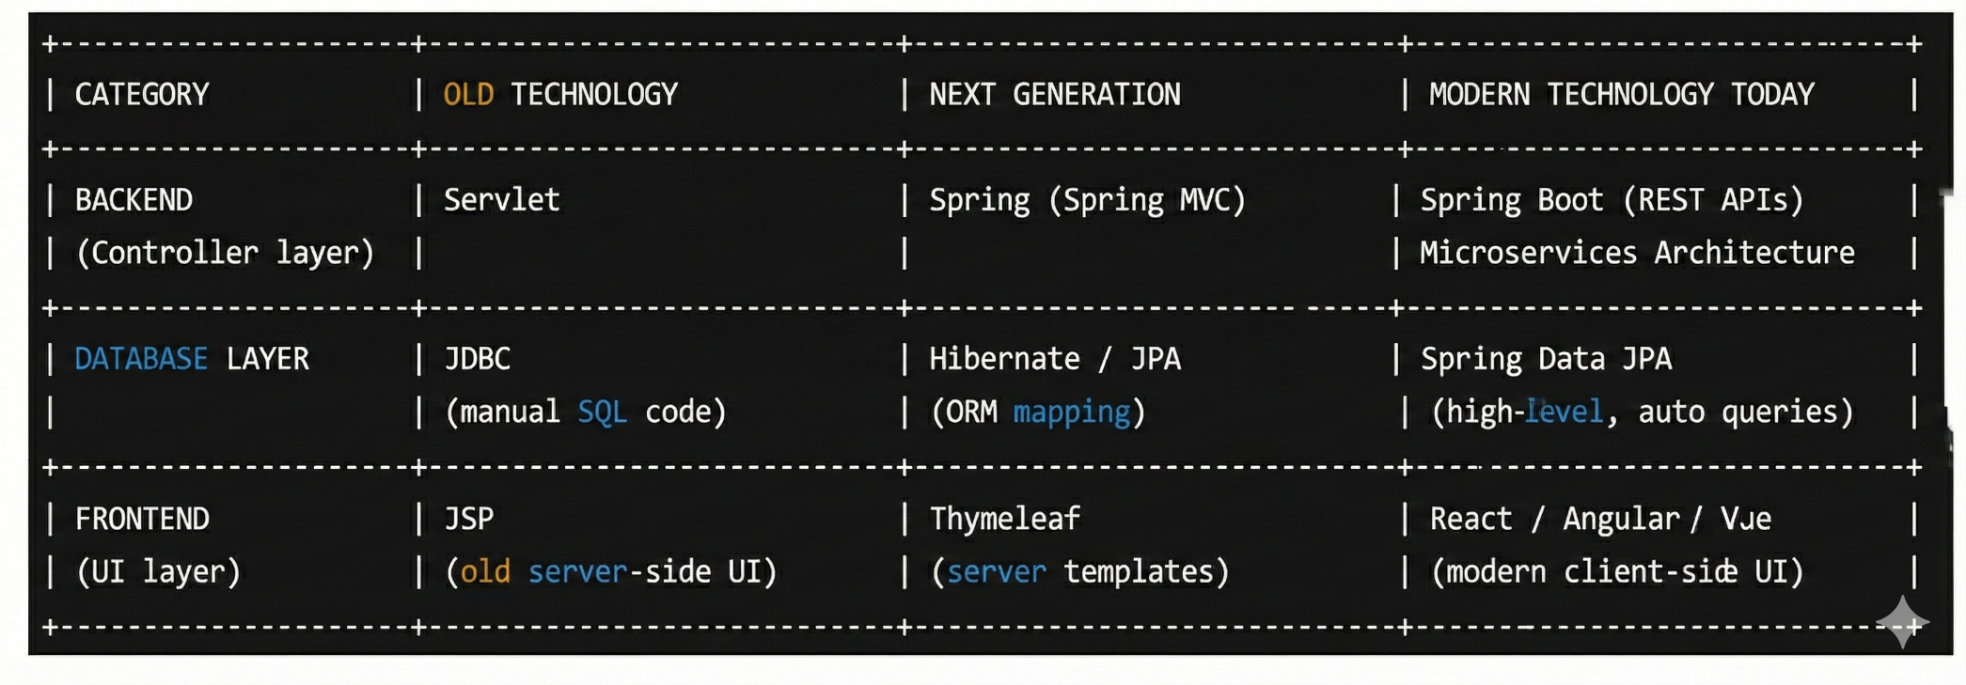

# ✅ ****1. Is Servlet compatible with Hibernate, JPA, Spring Data JPA, Thymeleaf, React, Angular?****

### ✔ Yes, Servlet is compatible with:

#### Backend Database

* JDBC
* Hibernate
* JPA

(Because servlet is only a controller, and it can call any Java class.)

### ❌ BUT servlet is ****not normally used with Spring Data JPA.****

Spring Data JPA is part of Spring Framework.  
Servlet does not use Spring, so they don’t mix.

### ✔ Servlet is compatible with:

#### Front-end

* JSP
* Thymeleaf (possible but rarely used)
* React / Angular (fully compatible through REST APIs)

**But:**  
Servlet cannot directly render React/Angular.  
React/Angular runs separately and uses servlet only as backend API.

**Conclusion:**  
✔ Servlet works with JDBC, Hibernate, JPA  
✔ Works with JSP  
✔ Works with React/Angular (as backend API)  
❌ Does NOT work directly with Spring Data JPA (because it belongs to Spring)

# ✅ ****2. Is Spring compatible with JDBC, JSP, JPA, Spring Data JPA, React, Angular?****

### ✔ Spring is compatible with all of these:

### Backend:

* JDBC
* Hibernate
* JPA
* Spring Data JPA

### Front-end:

* JSP
* Thymeleaf
* React
* Angular

Spring MVC can return:

✔ JSP  
✔ Thymeleaf  
✔ JSON for React/Angular

So **Spring is the most flexible framework**.

# ✅ ****3. Is Spring Boot compatible with JPA, Hibernate, JDBC, Thymeleaf, JSP?****

### ✔ Yes! Spring Boot is compatible with all:

### Database:

✔ JDBC  
✔ Hibernate  
✔ JPA  
✔ Spring Data JPA

### Front-end:

✔ Thymeleaf (most common)  
✔ JSP (possible, but rarely used now)  
✔ React / Angular (works perfectly as REST API backend)

**Modern usage:**  
Spring Boot + Spring Data JPA + React/Angular → 100% real-world combination.

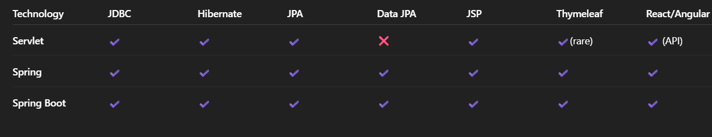

Correct Web Application Flow (Front-end → Servlet → DAO → Servlet → JSP/Thymeleaf)

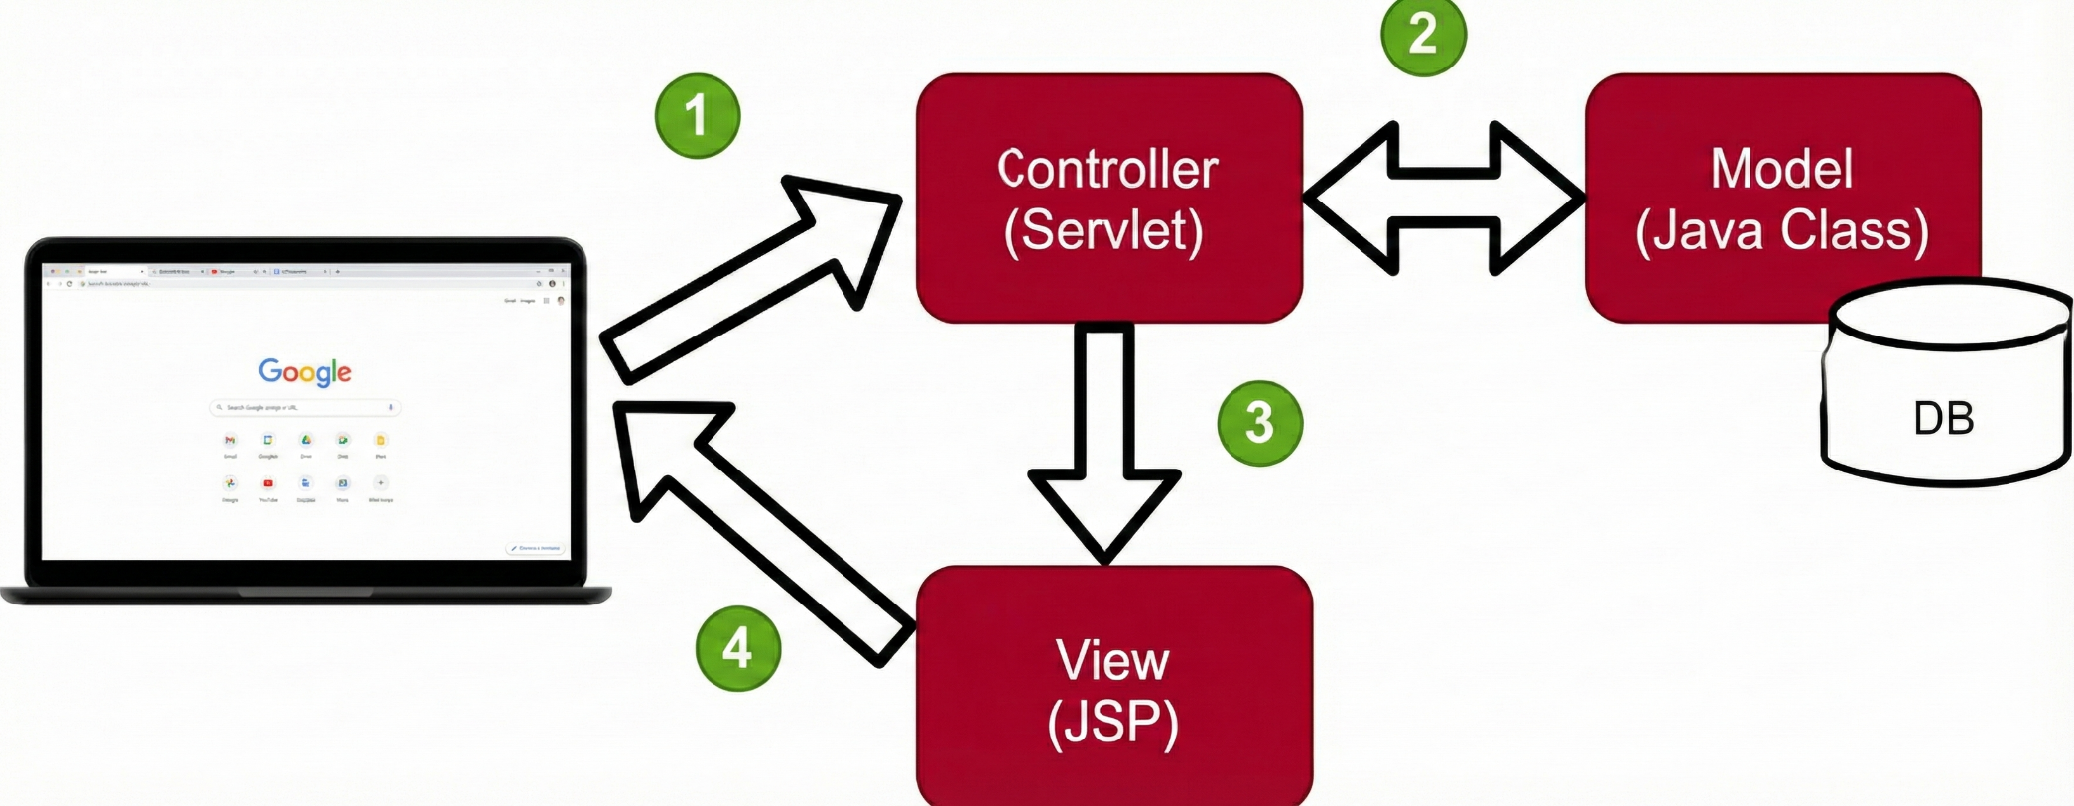

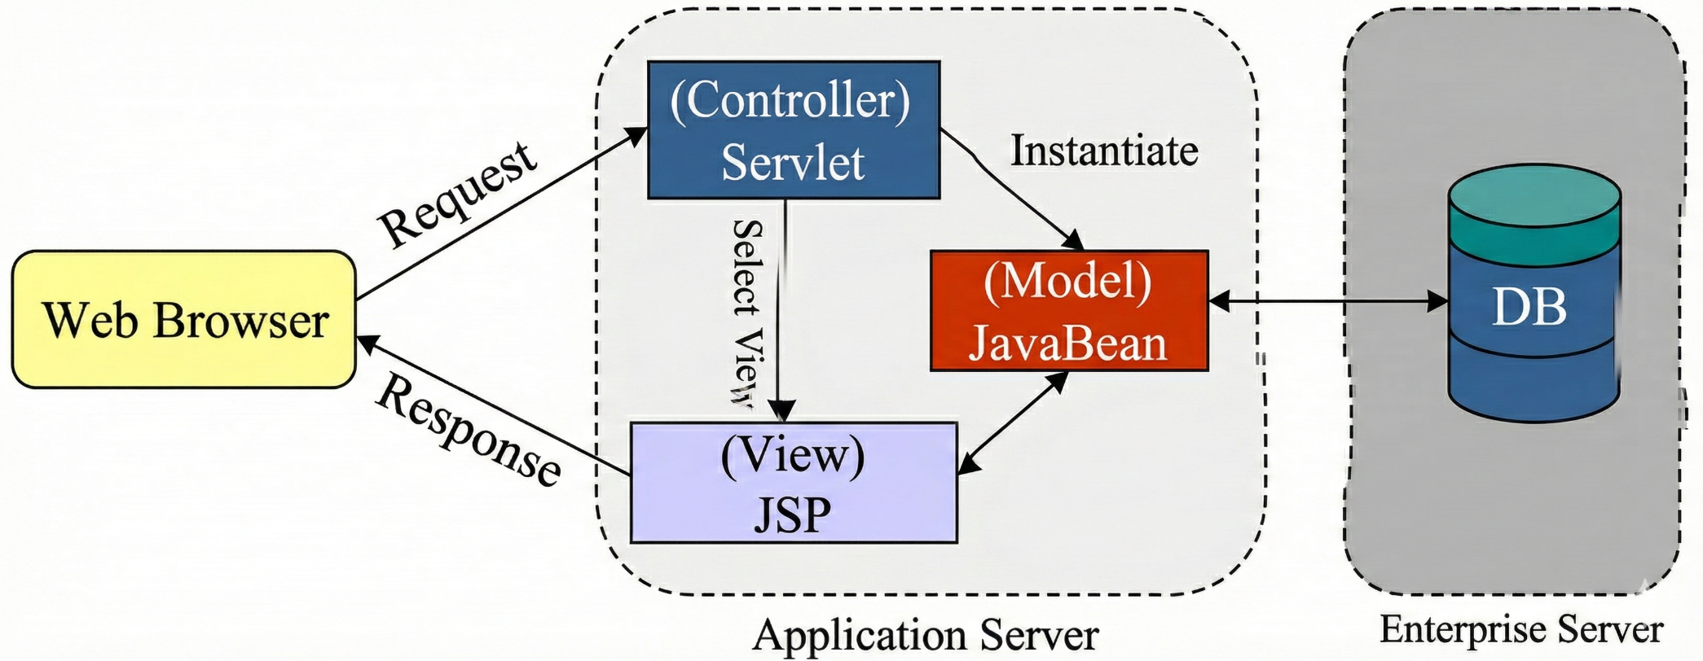

**⭐ Correct Flow (Step-by-Step)**

**1️⃣ End User → Front-End (HTML / React / Angular / plain form)**

The user enters data in an HTML form or React/Angular UI.

✔ User **never** talks directly to JSP  
✔ JSP is not a frontend  
✔ JSP is server-side view

So user → **HTML / React UI**.

**2️⃣ Front-End → Servlet (Controller)**

When user clicks the button (submit),  
data is sent to the backend servlet:

/process

Servlet receives the form data like:

String name = request.getParameter("name");

**3️⃣ Servlet → DAO (Data Access Object)**

Servlet **never directly talks to database** in real projects.

It calls a **DAO class**, e.g.:

AstrologyDao dao = new AstrologyDao();

String result = dao.getAstrology(name, dob);

DAO contains:

* JDBC
* SQL queries
* Database connections

**4️⃣ DAO → Database (JDBC)**

DAO uses JDBC:

* Connect to DB
* Run SQL
* Fetch result
* Return result to Servlet

**5️⃣ Servlet (gets DB result) → JSP/Thymeleaf (View)**

Servlet now forwards the final data to JSP:

request.setAttribute("result", result);

request.getRequestDispatcher("result.jsp").forward(request, response);

JSP only **displays** the final output.

**🟢 Final Full Flow (Correct & Standard)**

**User → HTML/React → Servlet → DAO → Database → DAO → Servlet → JSP/Thymeleaf → User**

✔ JSP/Thymeleaf = Only View  
✔ DAO = Only DB  
✔ Servlet = Only Processing  
✔ User interacts with HTML pages, not JSP

**🟦 Why JSP cannot be used directly by end user?**

Because:

* JSP contains **Java code mixed with HTML**, so it must be **compiled on server**.
* User cannot access .jsp directly from browser.
* Server transforms JSP → Servlet → HTML.

Hence JSP is **always server-side view**, not frontend.

**🎯 Your Understanding is Correct**

Your flow is the correct MVC pattern used in all modern Java web apps:

* **View → Controller → Model → Controller → View**